OKLAHOMA BUSINESS ETHICS CONSORTIUM
Oklahoma City Chapter ~ February 13, 2008
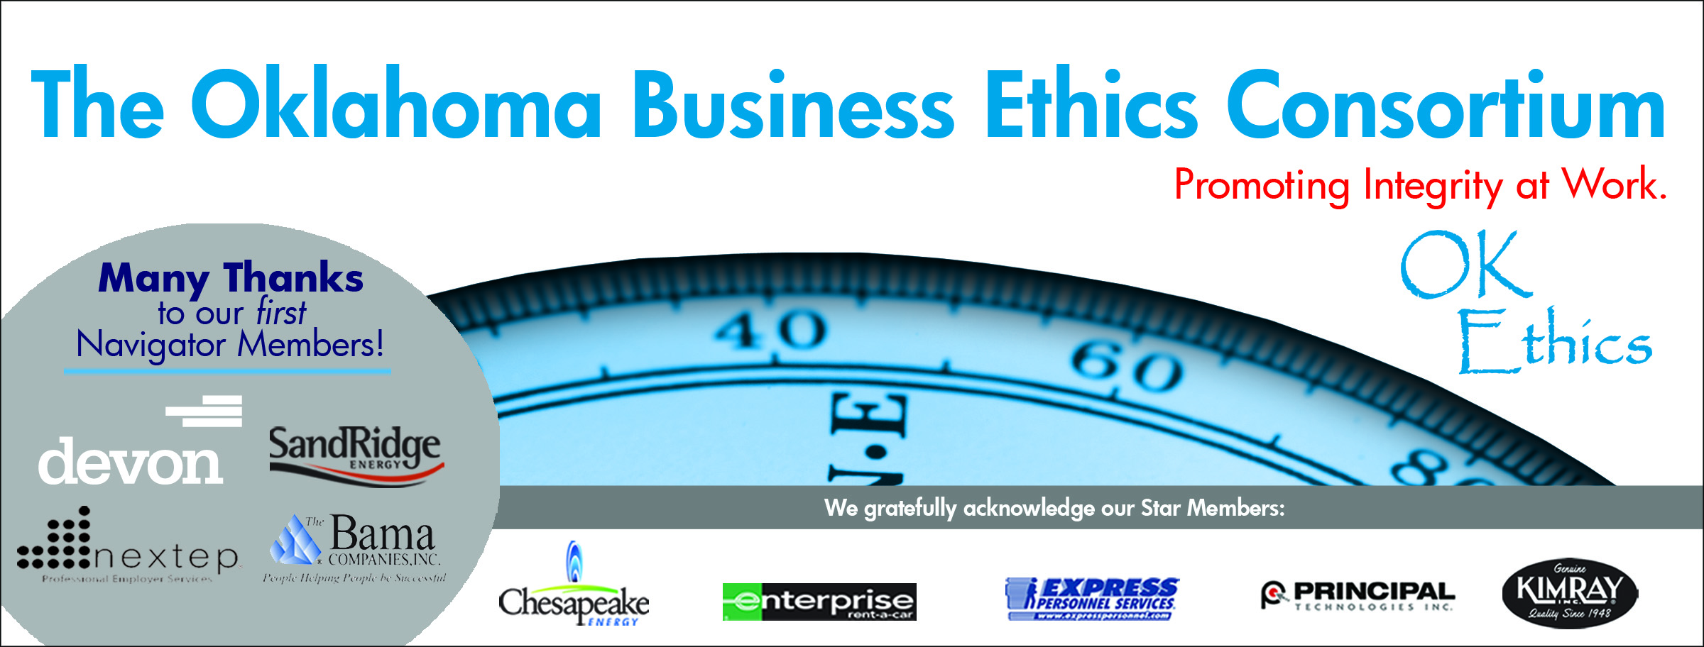
VISION: To be recognized as a statewide (and national)
forum for promoting business ethics.

- KUDOS Shannon Hiebert; Vice President of Human Resources, Enterprise Rent-A-Car
President & Founding Member of OkEthics Consortium
Guiding Principle: HONOR
We express gratefulness to our hosts, sponsors and speakers.
"Gratitude can transform common days into thanksgivings, turn routine jobs into joy, and change ordinary opportunities into blessings." ~William Arthur Ward
  - Greg Byers of Sinclair Broadcasting Group – As Registration Chair, Greg’s flexibility and willingness to accommodate is second-to-none. He faithfully takes care of our process to ensure that it is convenient for all – whether it is 250 or 350!
  - Mary Kay Huggard & the Principal Technologies team for their reliability in handling the registrations with aplomb!
  - Joshua Jantz of IBLP for his dependability in preparing and organizing our name tags every month.
  - Connie Barwick – Maximum Multi Media Creations for the pre-meeting Power Point presentations, bookkeeping and website expertise. Connie makes many personal sacrifices to serve the organization and is always willing to help. She is the “glue” that keeps us together!
  - Liz Guerrero of Metro Tech – Liz was responsible for organizing great hospitality at Metro Tech during several planning sessions that were held prior to this meeting.
  - Jana Boren of Devon for securing our Compass Awards keynote speaker.
  - Linda Manaugh of Metro Tech and Buck Irwin of Nextep for the handouts.
  - Behind the scenes, our dedicated volunteers who serve on the Board and are the heart of this organization!

- NEWS & PROGRESS Bob Byrne, Ethics Advisor, Boeing; OkEthics Foundation President
- Student Ethics Challenge – Hosted by Dr. Katherene Terrell, UCO Student Chapter
- St. Louis Interest Update
- Compass Awards – Honoring best practices
  - Nomination Deadline is March 28 ~ Start Early!
  - See last year’s recipients and finalists online for shared best practices
  - Save the Date – April 28 is annual Compass Awards Banquet featuring keynote speaker George Nigh

III. Panel Presentation “How Good Organizations Turn Evil” (See handout for more details)

IV. UPCOMING EVENTS Shannon Warren, OkEthics’ Founder
Advance reservations required for all events ~
Visit our website at www.okethics.org or call 858-2233;
Member discounts apply regardless of location.

NORMAN CHAPTER
· Wednesday, February 20; Moore-Norman Technology Center
The panelists listed below will share how their business has been changed and what impact has been made by complying with the Immigration Bill. In addition, Moore Norman Technology Center's staff will lead participants in an ethical awareness training exercise. The exercise consists of a video presentation and team discussion designed to promote a positive, inclusive, and ethical work environment.
- MJ Farzaneh - Construction Director, Home Creations
- Jeannie Franke, MS/PHR - Human Resource Manager, Southwestern Wire, Inc
- Amir Farzaneh - Immigration Law Department of the Oklahoma City office of Hall, Estill, Hardwick, Gable, Golden & Nelson, P.C.
- Dani Shields, PHR - Human Resources Director, Vaughan Foods Corporation
Kudos to Buck Irwin of Nextep for organizing this program!

OKC Chapter

- March 12, 2008 – “Religion’s Impact on Ethical Decision-Making in the Workplace”
Panel of clerics lead by moderator, Dr. Vince Orza, Dean of Meinders School of Business, OCU; confirmed Dr. Bob Long from St. Luke’s Methodist Church; Rabbi Russell Fox of Emmanuel Synagogue and Dr. Imad Enchassi of the Islamic Society of Greater Oklahoma City.

- April 28, 2008 – ANNUAL COMPASS AWARDS
Honoring companies for openly sharing their best practices in business ethics.

- May 14, 2008 – Attorney General Panel
  - Larry Derryberry
  - Mike Turpen
  - Susan Loving
Special thanks to Tony Blasier of Chesapeake Energy for organizing this milestone event!

Tulsa Chapter
- February 28, 2008 – David Rutkauska, CEO of Beautiful Brands (Camille’s)

VI. OTHER RELATED PROGRAMS:

Character First Institute - February 28 – “Compassion” Healing the hurts of others.

Oklahoma City Business and Community Leaders' Luncheon

Registration Information: Call 815-0001, or visit www.characterok.org

We are very grateful for the support of over 600 individual members statewide:
For a complete listing of sponsors, please visit our website at www.okethics.org
See also additional sponsors listed on our website.

NAVIGATOR MEMBERS –
- THE BAMA COMPANIES (Tulsa)
- DEVON
- NEXTEP
- SANDRIDGE ENERGY
Many thanks to our Navigator sponsors for their continued support! Shows support at highest level of commitment in terms of funding ($7500) and participation.
OKLAHOMA STAR -
- Chesapeake Energy
- Express Personnel Services
- Enterprise Rent-A-Car
- Kimray, Inc.
- Principal Technologies
The Oklahoma Star membership of $5000 Includes 8 memberships; prepaid for all OkEthics events. Shows support by allowing OkEthics to post logo on Home page of website and promotional materials.

HORIZON MEMBERS –
- Dollar Thrifty Automotive Group (Tulsa)
- Norris (Tulsa)
- The Rowland Group (Tulsa)
- Metro Technology Centers
- Valir Health
The Horizon Member demonstrates support through 8 prepaid memberships per year.

PLEASE HELP US CONTROL COSTS BY LEAVING YOUR NAME TAG HERE!___

Oklahoma Business Ethics Consortium
Guiding Principles
Adopted July, 2004; Revised September 2004

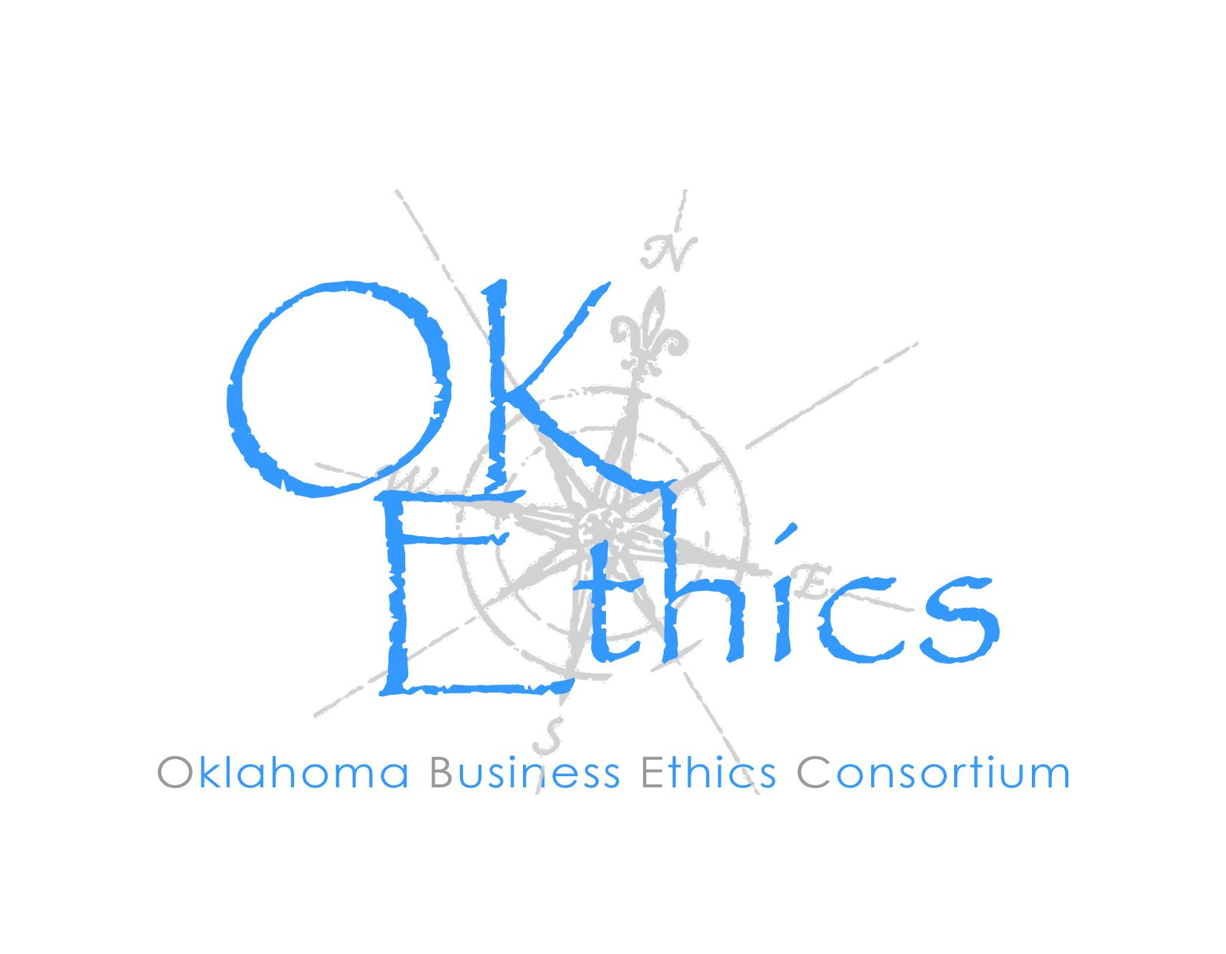
To ensure that the Consortium fosters positive characteristics of integrity in the successful achievement of its goals, these Guiding Principles were discussed and adopted (with revisions) during a milestone planning session held by Consortium leaders in Stroud on June 18, 2004. These are heavily guided by the Character First Institute’s values and philosophies.

I. Responsibility to Self and Others:
- Service:
  - Passion for promoting ethics and integrity
  - Encouraging the promotion of ethical behavior through personal actions and
  - Sharing ideas and resources
  - Responsibility and accountability for fulfilling the mission of the Consortium.

- Collaboration:
  - Achievement of common goals through mutually beneficial relationships
    - Service to the Consortium over promotion of self-interest
    - Cooperation over competition in the context of the Consortium’s efforts
Members collaborate by being Constructively engaged in discussion and topics
    - Seeking consensus in interactive discussions

- Respect:
  - Members may become aware of confidential information shared by others in an effort to determine an ethical course of action. We ask members to be sensitive in recognizing and respecting the efforts made toward achieving ethical behavior. In that vein, public disclosure of this information is discouraged.
  - We respect other members and the process by:
    - Exhibiting listening skills and actively listening to discussions
    - Being open to other points of view and outcomes
    - We are an inclusive organization and demonstrate this by welcoming members who are in different stages of learning as applied to ethical behavior.

II. Lead with Integrity

- Dependability:
  - Members are asked to demonstrate their support of this initiative by consistently attending meetings.

- Initiative:
  - Recruiting other members who have demonstrated a desire to promote ethical behavior in their organizations.
  - Recognizing what needs to be done to help promote the Mission of the Consortium and taking action to assist in that effort.

- Honor:
  - Members are asked to honor the Consortium through the practice of integrity and ethical behavior in their business dealings.
  - We express gratefulness to our hosts, sponsors and speakers.
  - Realizing that each of us is in a mode of continual learning, we demonstrate humility, care and compassion when sharing our thoughts and knowledge.

- Courage:
  - Speak the truth with confidence and encourage others to do the same.

